

Computer Games Development CW208
GDD
Year IV

Olawole Abayomi-Owodunni  C00278711 | Olawole Abayomi-Owodunni  C00278711
13th of April 2026

[Declaration form to be attached]

Contents

Acknowledgements 4
Game Overview 5
Feature Set 5
General Features 5
Editor 5
Gameplay 5
The Game World 6
Overview 6
The Physical World 6
Overview 6
Key Locations 6
Travel 6
Scale 6
Objects 6
Weather 6
Day and Night 6
Time 7
Rendering System 8
Overview 8
2D/3D Rendering 8
Camera 8
Overview 8
Camera Detail #1 8
Camera Detail #2 8
Game Engine 9
Overview 9
Game Engine Detail #1 9
Water 9
Collision Detection 9
The World Layout 10
Overview 10
World Layout Detail #1 10
World Layout Detail #2 10
Game Characters 11
Overview 11
Creating a Character 11
Enemies and Monsters 11
User Interface 11
Overview 11
User Interface Detail #1 11
User Interface Detail #2 11
Weapons 12
Overview 12
Weapons Details #1 12
Weapons Details #2 12
Musical Scores and Sound Effects 12
Overview 12
Red Book Audio 12
3D Sound 12
Sound Design 12
Single-Player Game 13
Overview 13
Single Player Game Detail #1 13
Single Player Game Detail #2 13
Story 13
Hours of Gameplay 13
Victory Conditions 13
Multiplayer Game 13
Overview 13
Max Players 14
Servers 14
Customization 14
Internet 14
Game Sites 14
Persistence 14
Saving and Loading 14
Character Rendering 15
Overview 15
Character Rendering Detail #1 15
Character Rendering Detail #2 15
World Editing 15
Overview 15
World Editing Detail #1 15
World Editing Detail #2 15
References 16

Acknowledgements
Thanks to Ryan Holloway for helping Play test the game
Thanks to Nina Drozd and Eanna O Cathain for the exposure to realise I could create something like this.

Game Overview
Space Raiders is a procedurally generated 2D Isometric Dungeon Crawler where the player dives into a pit of enemies and destroys them for loot and glory.
The main pull of Space Raiders is the incorporation of a Local LLM Model powering the NPC’s of the Hub world as well as background lore generation for rooms within the dungeon. The player can exchange words with NPC’s by sending them messages and receiving responses as well as enjoy a diverse set of quests to do that feel authentic due to the lore behind each quest being unique. LLM Technology has been around for quite a while and we haven’t seen the application of local inference in games. This is an area I have a deep interest in and so ventured forth into working on this game.
The game takes place in the Aquila galaxy, lightyears away from Earth’s milky way. You play as Isiah, a space ranger who goes from ship to ship scavenging for resources and supplies from desolate pirate spaceships. The galaxy is a hotbed for piracy which means you always have work to do, ridding your space of the vermin, one contract at a time.
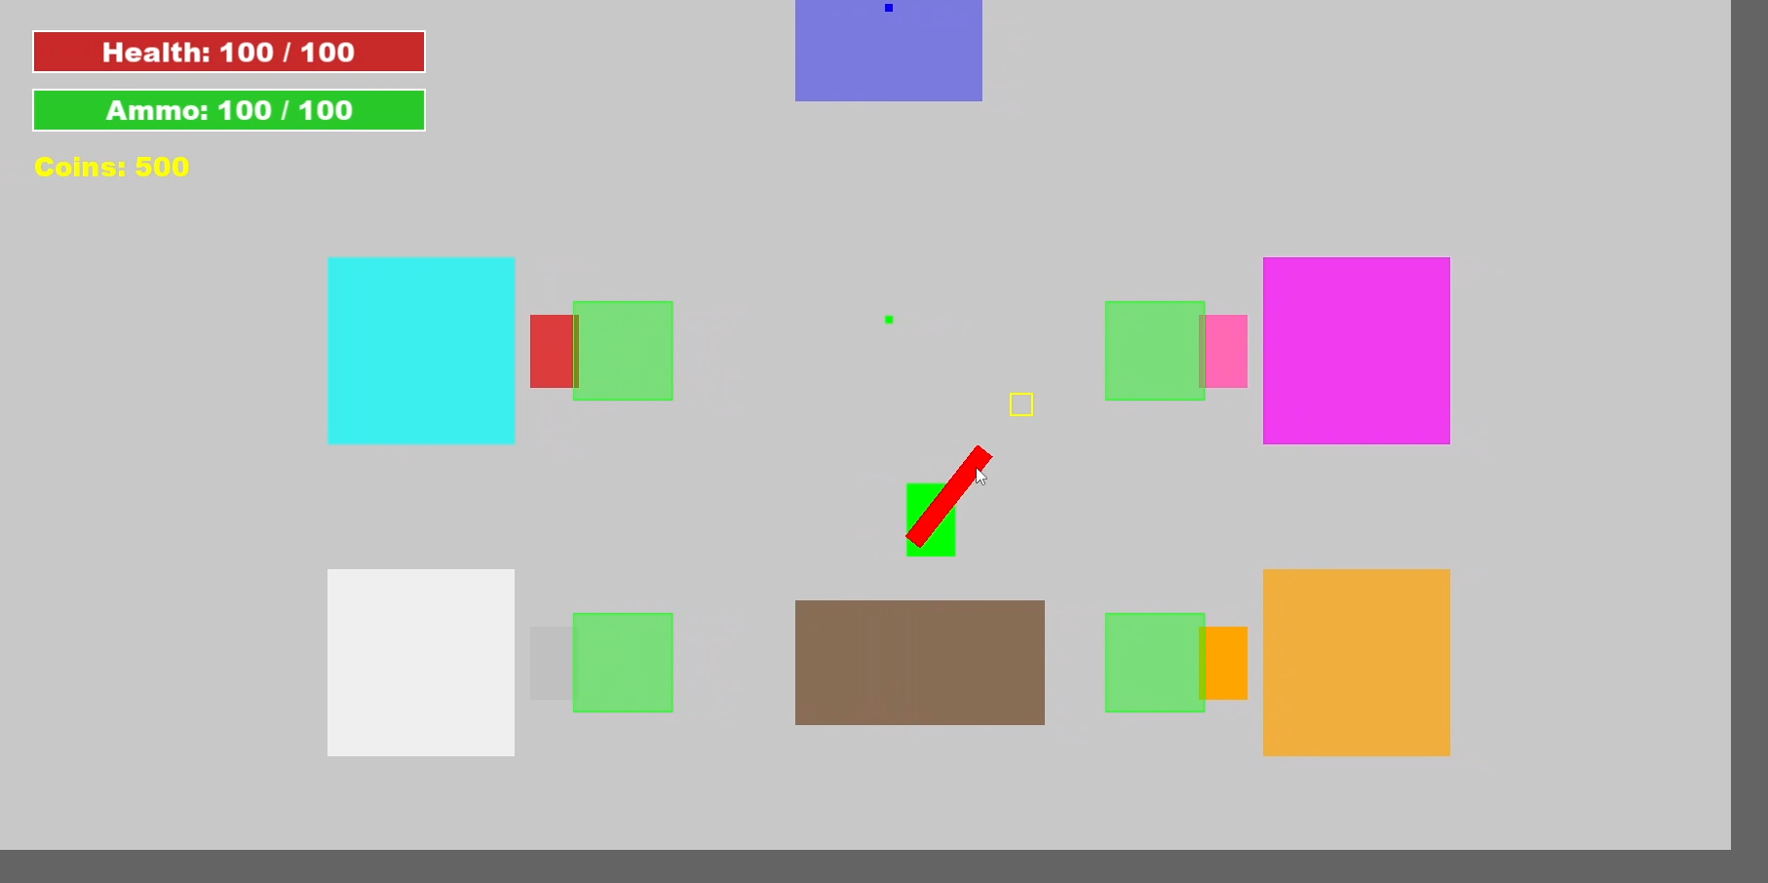

Feature Set

General Features
- Procedurally Generated Dungeon with seeds so you can play the same levels with friends
- Dynamic Quests
- High score Tracking

LLM Feautres
- Can talk to NPCs in game
- Dynamically generated lore behind quests
- Dynamically generated lore behind rooms in levels

Gameplay
- Player Upgrades
- Character Upgrades
- Weapon Upgrades
- Character Customisation
- Multiweapon handling
- Interactable NPC’s with Unique personalities

The Game World

Overview
The Aquila galaxy is a place full of lawlessness and chaos. Pirates roam the galaxy stealing, looting and plundering as they please. The character you play, Isiah is a bounty hunter crew member on the Stellaris7 ship along with Gunther, the Black market dealer, Arthur, the ships weaponsmith, Cassandra, the ships resident doctor and Leandra, the fashionista stowaway.
Stallaris 7 (The Hub World)
The Stellaris 7 is the last of a mighty fleet that Isiah just so happens to find himself a part of. It is fully equipped with a weapon armoury, manned by Arnold, a state-of-the-art med bay run by Petra, a fully loaded black market weapons stash under the possession of Gunther and a food hall turned fashion closet made by the resident fashionista Cassandra
Other Ships (The dungeons)
The other ships the player navigates through are complex labyrinths of enemies and treasure. There’s never an end to them which also means there is a never-ending supply of resources right at your fingertips.

The Physical World

Overview
The world the player interacts with is split into 2. The Hub world and the Dungeon rooms.

Key Locations
Hub World (Stellaris 7)
Dungeons (Enemy pirate ships)

Travel
The player runs around the world with his biomechanical legs

Scale
The player is average human size. The view the main camera views them from is at a height where they can see multiple other enemies in their vicinity.

Objects
- Stim Packs are health packs that the player finds in the world which heal them. Picking one up gives you 10 Health Points

- Ammo Crates replenish the player’s global ammo socket (ammunition). Picking one replenishes 10 Ammo

- Coins are currency in the game that enable you to purchase upgrades to your character. Picking one up adds 5 coins to your total

Time
The player is timed on how long it takes them to complete a level. The faster they clear the level whilst dealing as much damage as possible, the better their final score at the end of the game.

Rendering System

Overview
The game is built using 2D SFML shapes mainly meant for debugging but there is a certain charm to them. Rendering pipelines that call m_window.draw() are attached to entities and ‘spawn-ables’ and are drawn in the main render loop. The perspective is top down.

2D/3D Rendering

Camera

Overview
There are 2 Cameras. One attached to the player and another to enable the player to view the layout of the ship

Player Camera
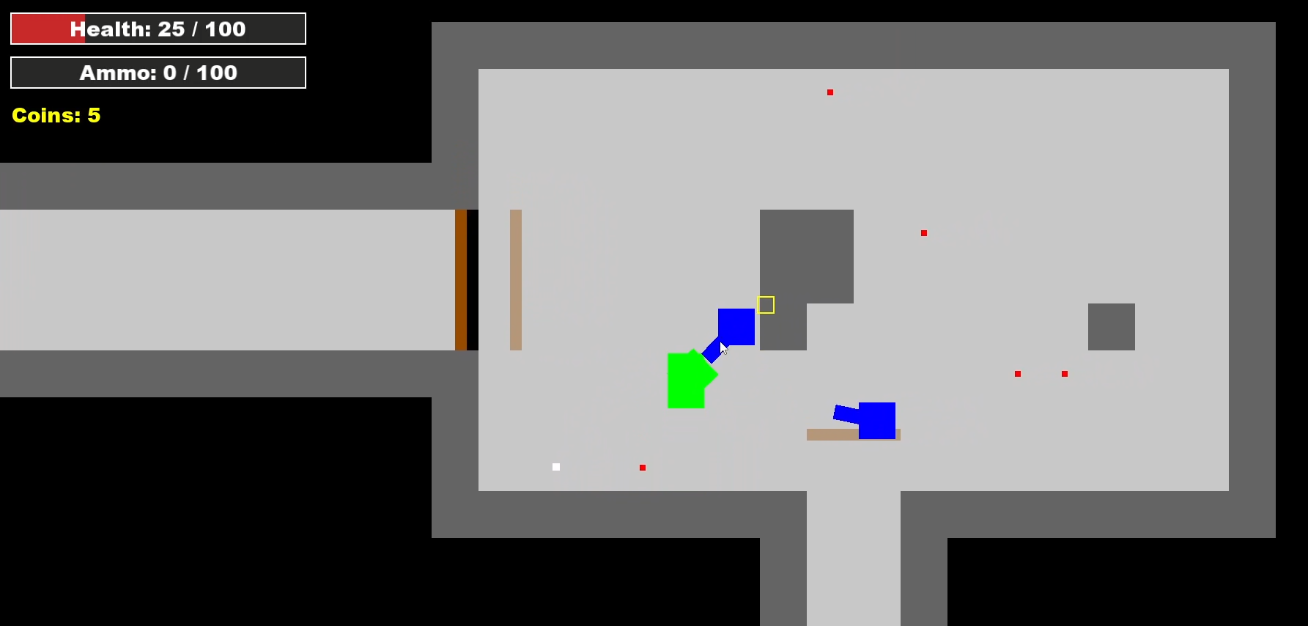
The camera is attached to the player and moves as the player moves.

Floor Camera
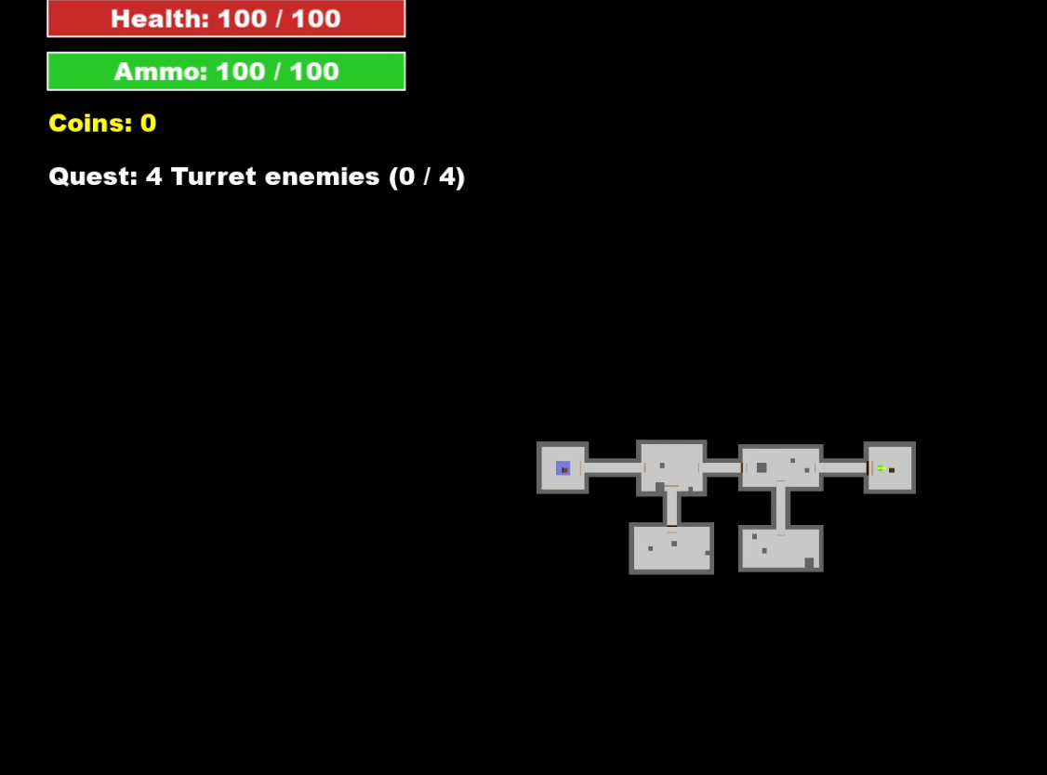
This Camera is a static camera that shows the layout of the entire dungeon to provide the player with a means of navigating Dungeons.

Game Engine

Overview
This game was programmed using C++ and SFML. There is a separate wrapper component that uses llama.cpp backend’s inference functions and that is then built into this project using CMake.

SFML
SFML (Simple and Fast Multimedia Library) is an open-source, cross-platform software development library designed to provide a simple interface for building 2D games and multimedia applications. It offers modules for graphics, audio, networking, and window management, primarily designed for C++. SFML provides a simple interface to the various components of your PC, to ease the development of games and multimedia applications. (SFML, 2026).
The game engine will keep track of everything in the world like such and such.

Game States
Like the main menu, pause screen, Hub World, Dungeon world. Manging the state of the game

Collision Detection
Collision Detection is being done via a custom static collision class that uses AABB style collision and Layers/Masks. An interface Collidable (ICollideable) class mandates every class that inherits it must return a collision profile which is the objects layer and what masks it can collide with (Like how a traditional Game Engine would run). Using this, a custom function that checks if the 2 objects of type ICollideable are intersecting and returns true if they are. Once this is true, the 2 objects can follow the logic to be implemented post collision.

The World Layout

Overview
The player spends down time in the Hub World and Game time in the Dungeons.

Hub World
This is where the player spawns by default.
- The blue square represents a Weapons shop where the player can spend coins to upgrade the ammo count or weapon level.
- The Magenta square represents the customisation booth for the player where they can change the colour of their player.
- The white square represents the Armoury where the player can swap out their weapon
- The orange square represents bio-lab where the player can upgrade their maximum health and speed.
There are NPC’s standing directly outside their respective stores and they can be interacted with by stepping into the green triggers and hitting the interact key (See example below).
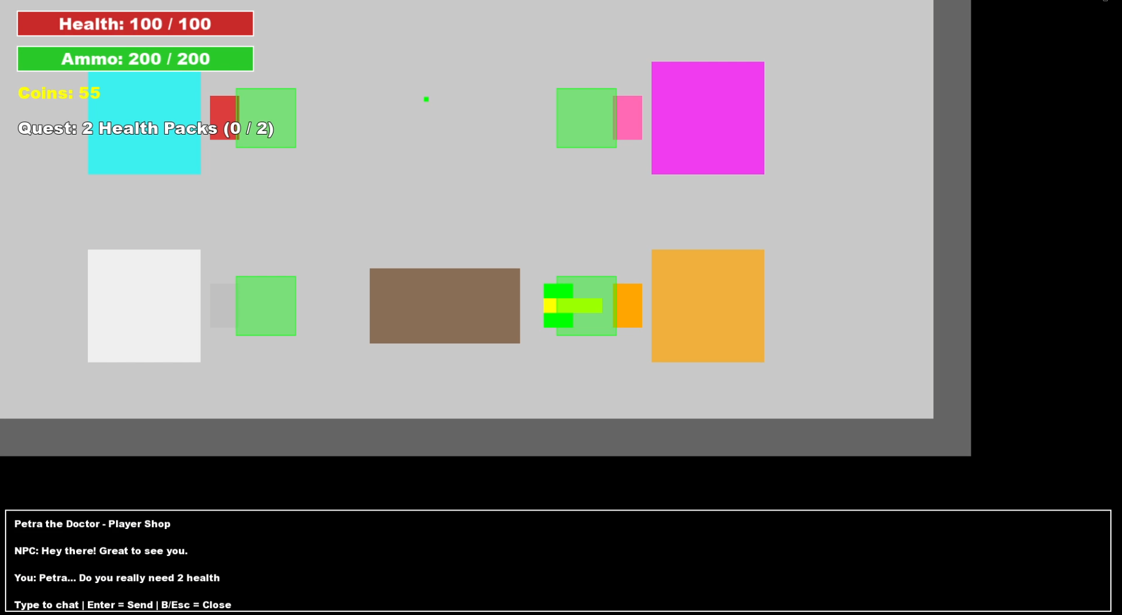
The brown square represents the job board where the player can pick up jobs to make some more money for upgrades. These jobs include Kill contracts and Fetch quests but the description of these quests is fully generated by the Local LLM powering the game.
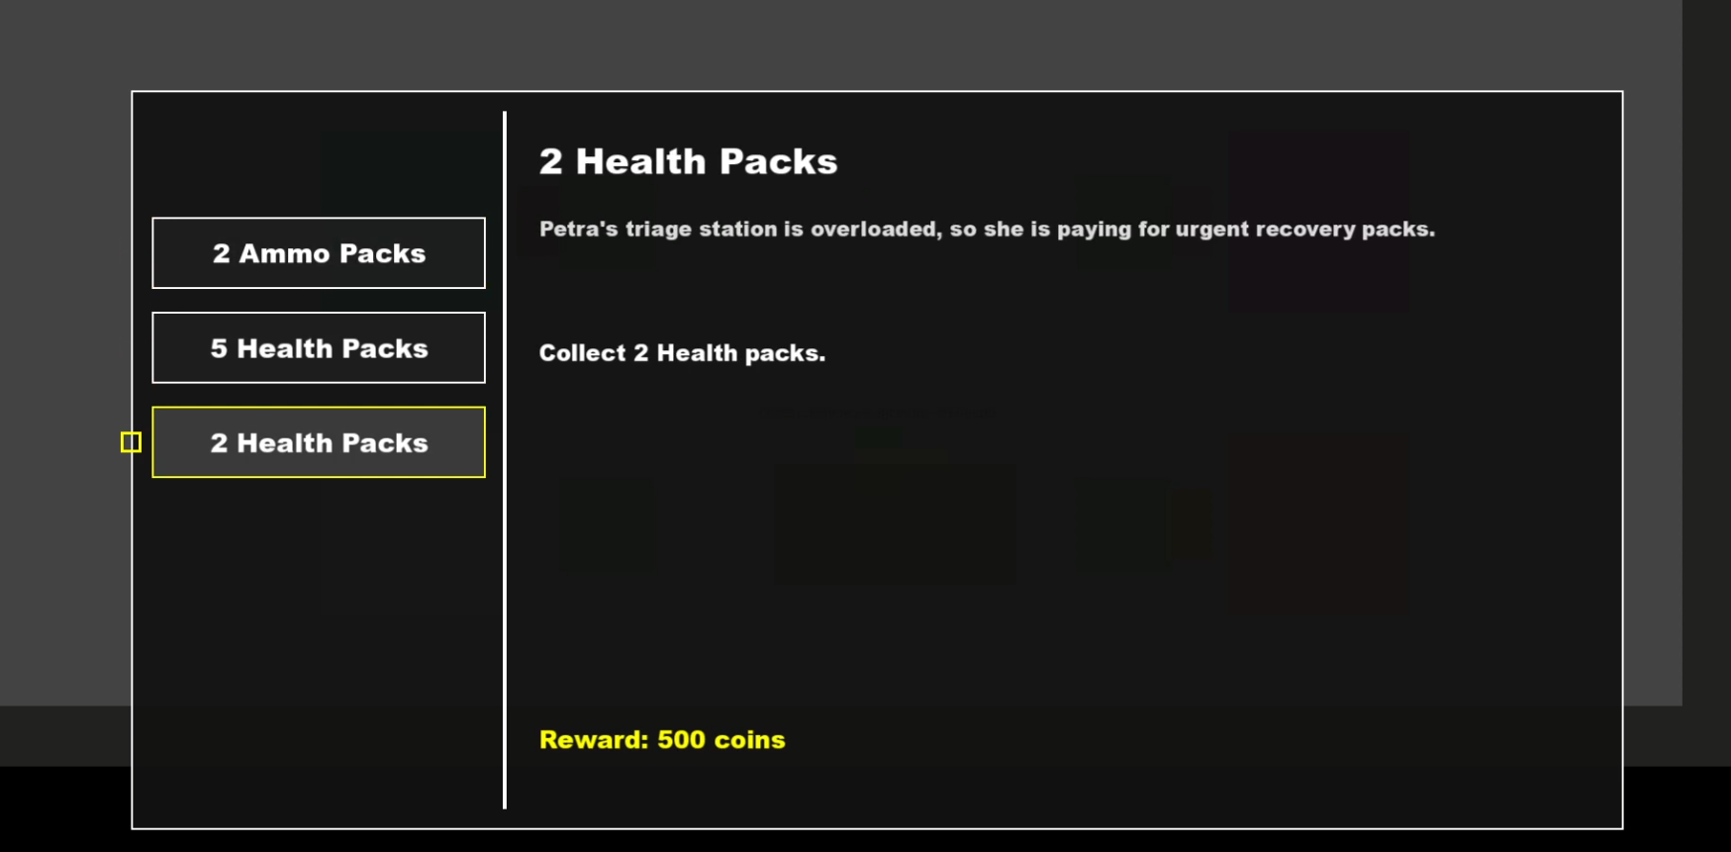
World Layout Detail #2

The Dungeons
The dungeons are procedurally deterministic levels built using 3 layers. Rooms, Floors and Dungeons.
- A room is the most basic of the 3 and does a lot of the heavy lifting. This is where rendering is done room specific logic and tracking as well like Combat rooms managing waves.
- A floor is a graph that builds a series of nodes and connections based on how many rooms were to be made. It then connects these nodes and appends them to a list room plans (structs that contain meta data about the room). The ordering of these rooms as well as how many to construct is deterministic (randomly chosen with a seed. You will get the same room every time).
- This deterministic trait is handled by the Dungeon. All this does is call a floor to be made 3 times and then contains the dungeon seed that each sub category (floors and rooms) append their metadata ID to.

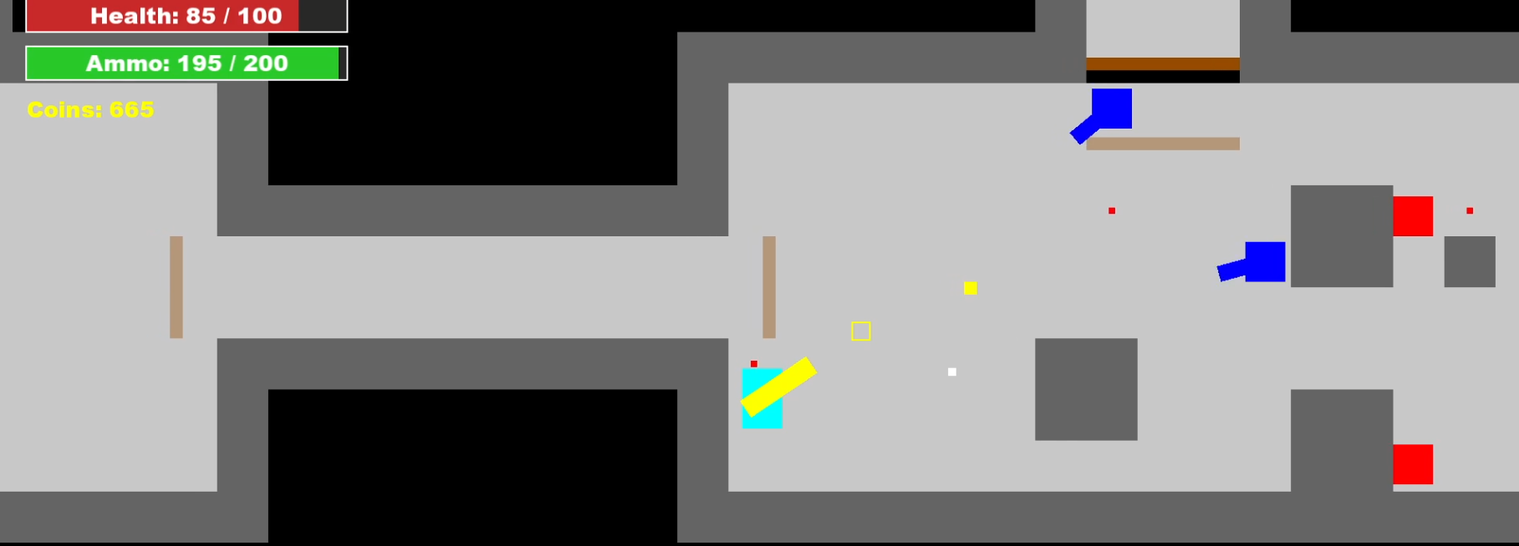

Game Characters

Overview
You play as Isiah, a humanoid character that fights turrets and enemy grunts. The members of your ship are also humanoid

Gunther:
- Shop Owner: Weapon Shop
- Personality: Greedy
- Background: Black market Dealer


Cassandra:
- Shop Owner: Cosmetic Shop
- Personality: Passionate
- Background: Former adventurer turned Fashion Guru


Arnold:
- Shop Owner: Armory
- Personality: Professional
- Background: Master weaponsmith; Highly Intelligent


Petra:
- Shop Owner: Customisation Shop
- Personality: Friendly
- Background: Skilled medic; Shady

Customising a Character
To customise your character, go to Cassandra’s shop and interact with it to put on a different skin.
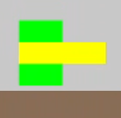 -> 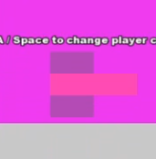 -> 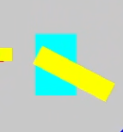

Player Upgrades:
The player has access to the customisation shop where they can upgrade the Health and Speed of their character for 100 coins.

Combat:
The player moves using the left stick or WASD and controls the reticule using the rigtht stick or mouse. Left click or Right Trigger to shoot and Q and E or Right and Left bumpers to swap between weapons
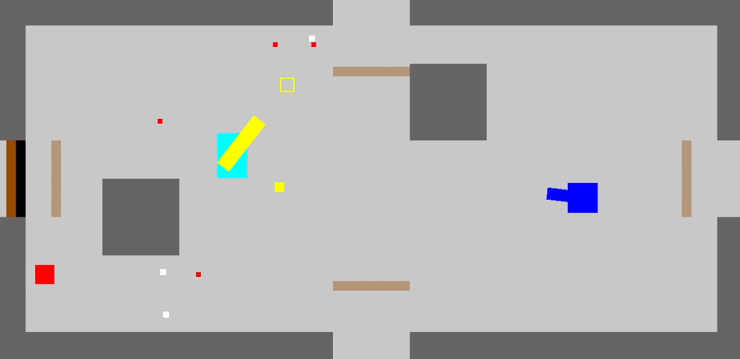

Enemies
There are 2 types of Enemies in game:

Grunts:
- Follow the player the around and when the arrive at their position, they launch a melee attack to do damage to the player
- 

Turrets:
- Stationary targets that fire projectiles every 1 to 3 seconds that damage the player for 10 health
- 

User Interface

Overview
The game consists of Menu screens and certain conditional HUD elements. These are the Main menu screen, Pause screen, Job board screen, Game over screen, Player HUD and NPC Dialogue panel and Room Description Panel. In most menus you can see which option is currently selected via the highlighted shape

Main Menu
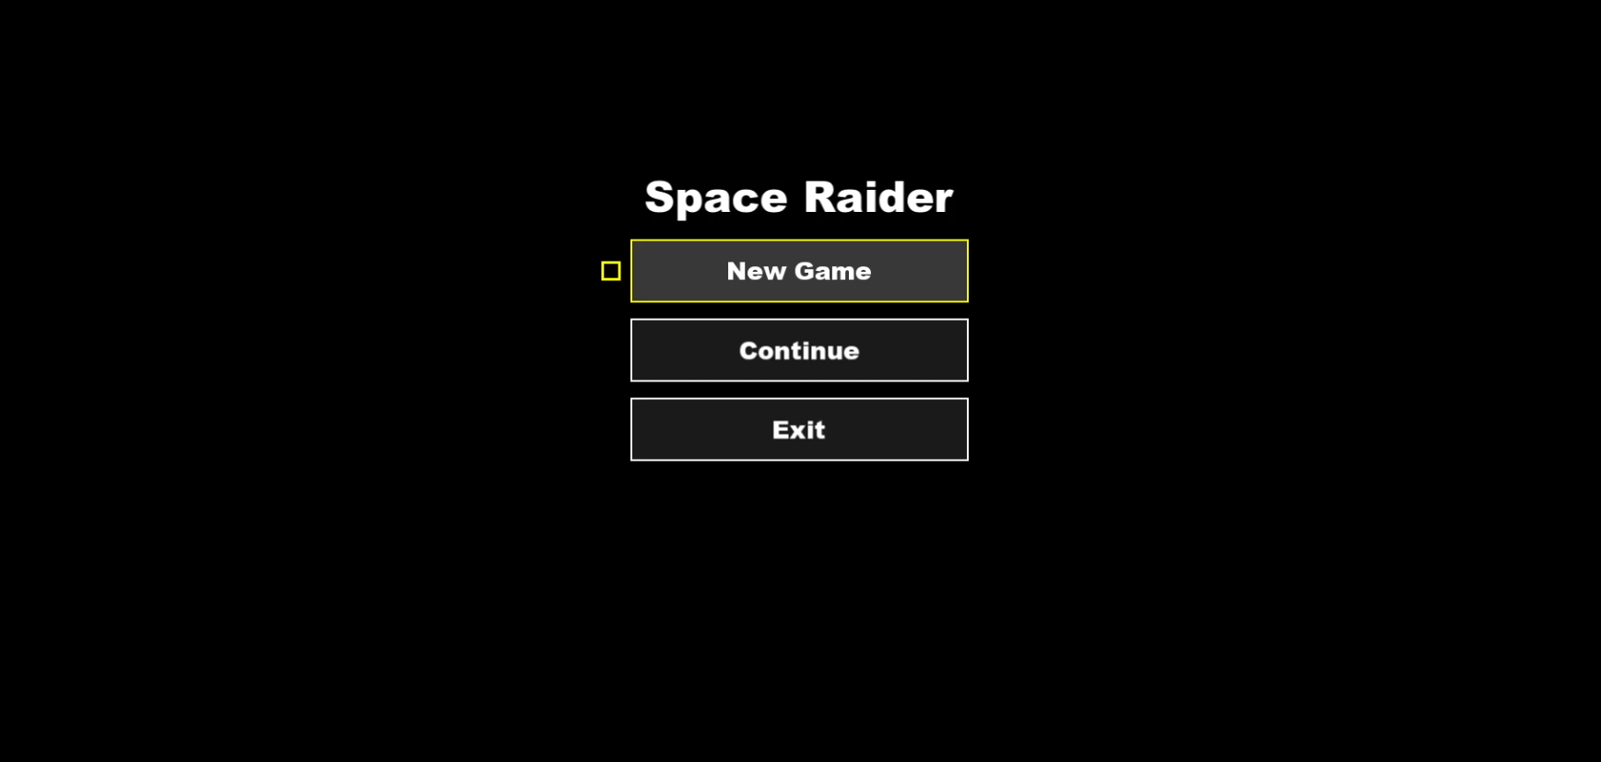
Contains:
- Game Title
- New Game Button (starts brand new instance of the game)
- Continue Button (Resumes game state)
- Exit Button (Quits the application)

Pause Menu
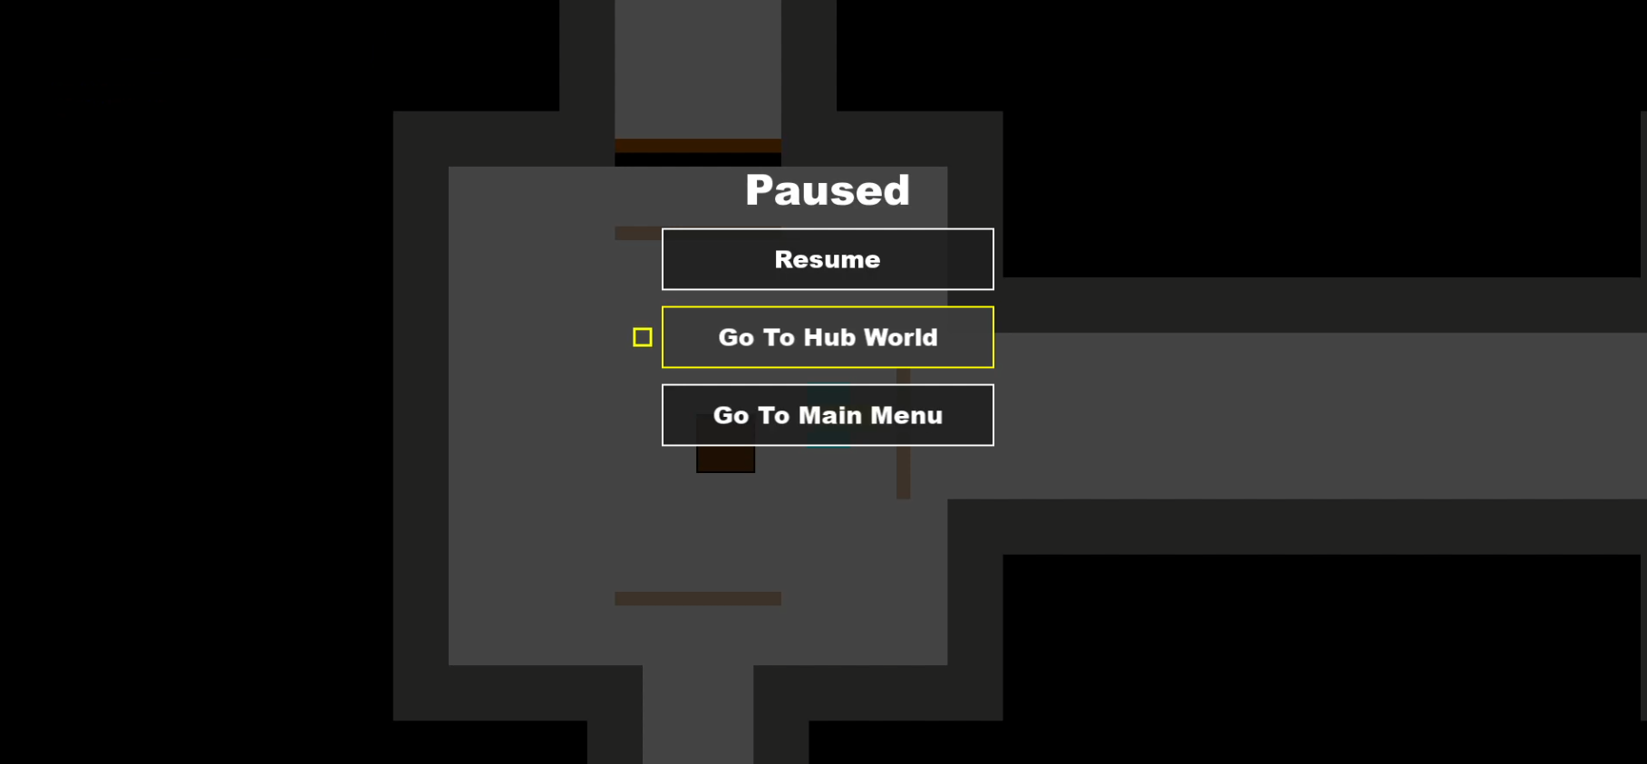
Contains:
- Menu Title -> “Paused”
- Resume Button (Resumes current game state)
- Go To Hub World Button (Takes player back to Hub World)
- Go to Main Menu (Takes player back to main menu)

Job Board Screen
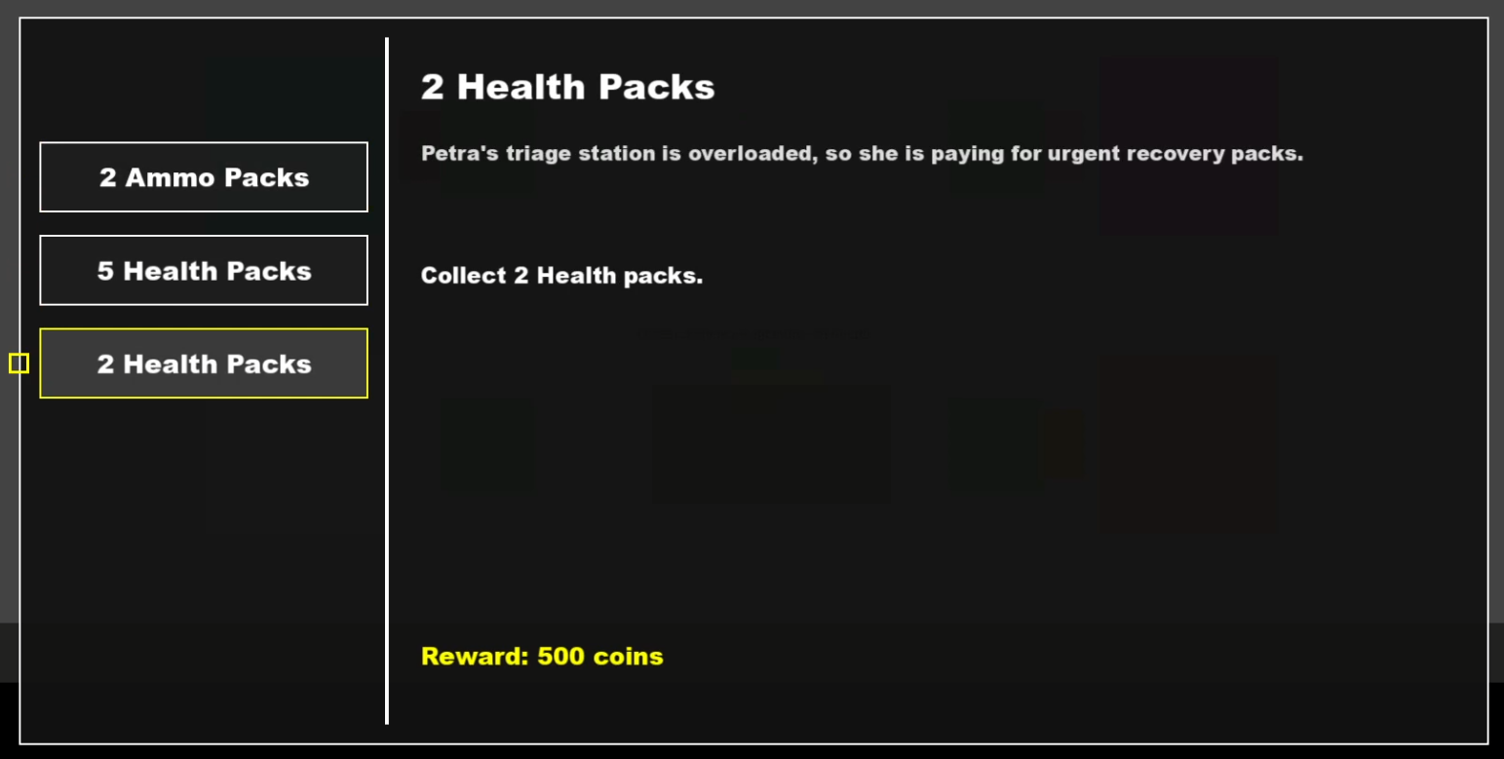
Contains:
- Panel encapsulating Quest information
- 3 Buttons, each representing its own quest. Player can click using the mouse or navigate using the A button and d-pad on controller
- Title of Quest at the top corner and on the label of the button
- Lore Description of the quest
- Objective of the quest
- Reward for completing quest

Game over screen
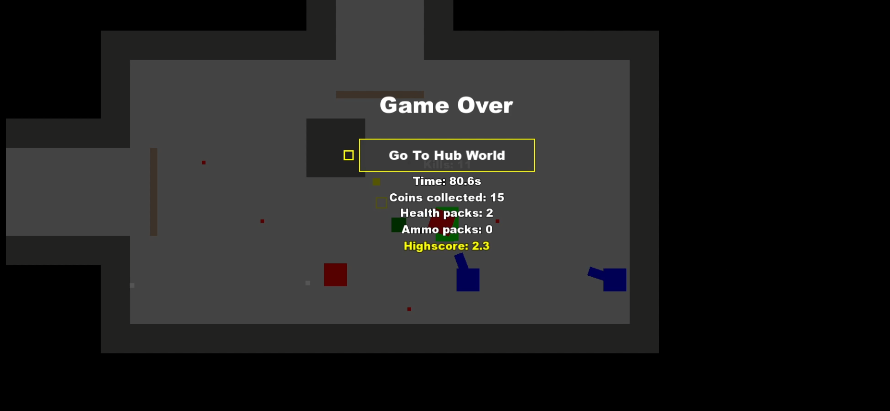
Contains:
- Game Over text
- Return to Hub World Button
- Player stats from run

Player HUD
Contains:
- UI showing player remaining Health and max Health
- UI showing Player remaining Ammo and max Ammo
- Current coins
- Quest Tracker (if there is an active quest)

NPC Dialogue Panel
Contains:
- NPC being spoken to
- User input
- Instructions on how to use dialogue menu

Room Description Panel

Contains:
- Text of room description
- Panel encapsulating text.

Weapons

Overview
The combat system consists of 2 types of weapons. Melee and Projectile based weapons.

Melee Weapons
Knife:
- Very Fast attack speed
- Low damage
- Small range
Sword:
- Fast attack speed
- Medium damage
- Long range
Axe:
- Slow Attack speed
- Massive Damage
- Wide range

Projectile based Weapons
Pistol:
- Fires one bullet at a time with very low fire rate
- Consumes one AMMO per shot
- Deals Medium damage per hit
Assault Rifle:
- Fires consecutive bullets at a time with a high fire rate
- Consumes one AMMO per shot
- Deals Low damage per hit
Shotgun:
- Fires 5 bullets at once that spread outward
- Consumes 5 AMMO per shot
- Deals low damage per Pellet

Single-Player Game

Overview
The core gameplay loop consists of the player spawning into the hub world, making some purchases to upgrade their character, interacting with the NPCs to gain some insight on the level you are about to enter and then selecting a quest to do whilst in the dungeon.
Once the player is in the dungeon, the player goes from room to room, till they get to the portal room which takes them to the next floor of the dungeon. Between the portal room and the spawn room are combat room s where the player must fight off waves of enemies till all enemies have been defeated. There is a chance the player might receive a reward in the form of a chest on room completion and as the player defeats enemies, there is the chance for enemies to drop quest items such as health or ammo for the player to pickup.
Here is a breakdown of the key components of the single player game.

Quests
The player picks a quest to undertake for their next run in the dungeon by interacting with the Job board in the hub world and selecting one of 3 available quests. This quest is made up of either a fetch quest or a kill quest. On fetch quests, the player must retrieve a certain number of items and make it back to the hub world to claim the reward. Upon completion of the quest, the player is credited with the reward from that quest.
Fetch quests include receiving a certain number of health or ammo pickups
Kill quests include destroying a certain number of specific enemy types (Grunt or Turret)

Player and Weapon Upgrades
The player upgrades their gear with the money made from venturing the dungeons. When they return, they spend that money to make their character more powerful.
Gun Upgrades increase fire rate and damage
Ammo Upgrades increase ammo capacity, allowing the player to use their gun for longer without having to switch to your melee
Player upgrades increase total Health capacity, allowing the player to tank more hits before they Game Over.
Speed upgrades increase the players movement speed for faster traversal of the rooms within the dungeon.

High Score
As the player goes deeper into the dungeon, the better the score gets. This, coupled with the ability to choose which dungeon seed they would like to go through, allows friends to compete against each other and fight for better scores against each other.

Hours of Gameplay
The main draw of the game is for players to attempt to best their own score when playing alone. Jump into a dungeon, make money, get out, upgrade stats, perform better, repeat.

Victory Conditions
The player must reach the final level of the dungeon and then get to the final Portal. Once they cross the final portal, they successfully complete the Dungeon.

Persistence
The Player’s upgrades and current economic state are saved between runs.

Character Rendering

Overview
The static shape objects are passed to the render function when in debug mode but in Game mode, the render mode switches to use the sprite animation class that showcases the Game assets.

Debug Rendering:
Rendering done via passing sf::rectanlgeShapes into m_window.draw() function

Release Rendering:
Rendering done via a custom animate sprites function that takes in a spritesheet and the desired timings and loops through the selected frames that change based on the input/action provided.

References

Web-site
SFML (2026) Simple and Fast Multimedia Library. Available at: https://www.sfml-dev.org/
(Accessed: 13 April 2026).

